Mountain Bike Geometry Optimization and 3D Frame Modeling
Overview
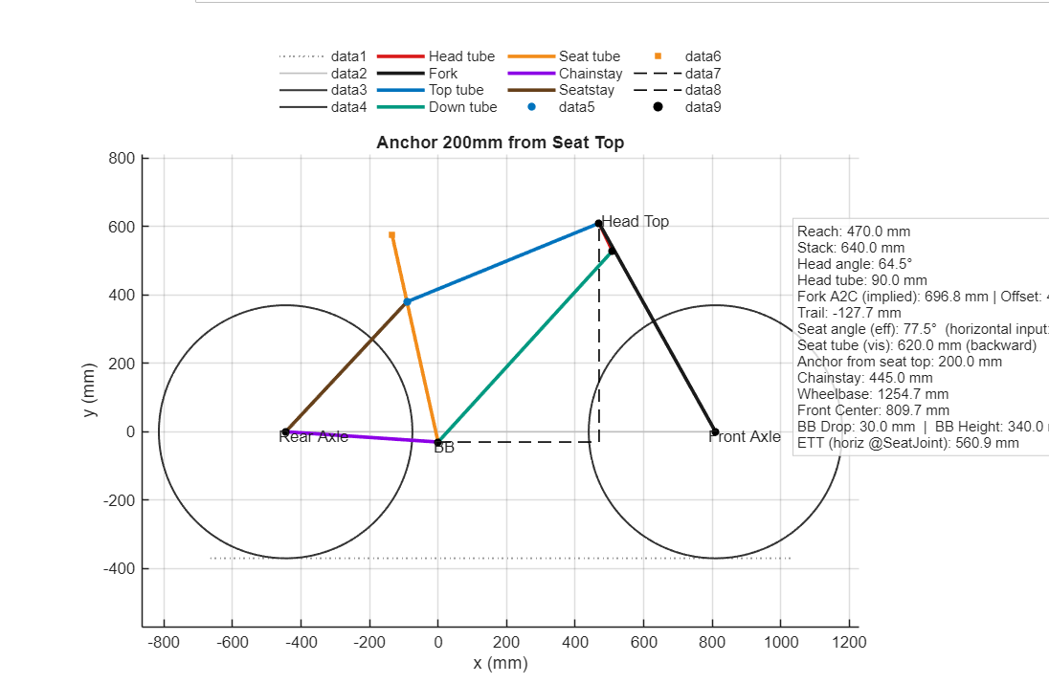
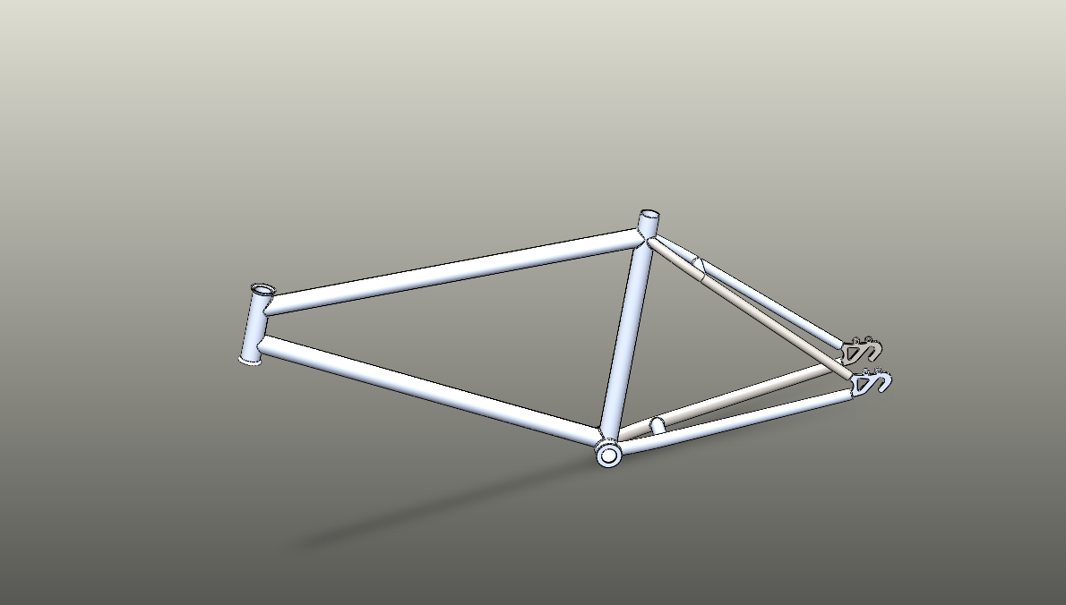
This project explores the geometric analysis and personalized optimization of a mountain bike frame using computational modeling and 3D CAD design. The goal is to develop a mathematical and engineering approach that connects rider body measurements with optimal frame geometry for improved fit, comfort, and handling.

Objectives
To build a MATLAB-based computational model that calculates key geometry parameters such as stack, reach, head tube angle, seat tube angle, top tube length, and wheelbase, based on rider measurements including height, inseam, torso length, and arm span. To create a 2D geometry draft in MATLAB to visualize the relationships between these geometric parameters. Additionally, develop a 3D frame model in SolidWorks using the computed geometry.
To plan a future static structural analysis (FEA) to evaluate stress distribution and mechanical strength across different frame designs.

Technical Approach
The project began by deriving mathematical relationships between rider anthropometric data and key geometric parameters of a mountain bike. MATLAB was used to automate geometry calculations and generate a 2D frame. The computed geometry data was then imported into SolidWorks, where a full 3D model of the frame was reconstructed. This allowed for verification of tube intersections, joint connections, and alignment accuracy. In the next stage, finite element analysis (FEA) will be integrated in SolidWorks to simulate static loads, identify stress concentrations, and guide further geometric refinement.
Key Skills
This project combines several engineering skills, including MATLAB programming for automated computation and visualization, SolidWorks modeling, and mechanical design reasoning. It also demonstrates planning ability for extending geometric modeling into structural analysis through FEA.
-Outcome
The project resulted in a personalized mountain bike geometry dataset based on rider-specific inputs, a MATLAB-generated 2D visualization of the frame with labeled dimensions and angles, and a complete 3D SolidWorks model suitable for future static

